An Access Matrix is a digital model utilized to control and manage permissions. This model defines the rights each user has for different resources. In simple terms, it’s a table that shows what actions an individual or a group of users can perform on specific objects within a system.

It represents the access control mechanism that specifies which actions (e.g., read, write, execute) are allowed or denied for each subject on each object.

Different Types of Rights
There are different types of rights the files can have. The most common ones are:

Read- This is a right given to a process in a domain that allows it to read the file.
Write- Process in the domain can be written into the file.
Execute- The process in the domain can execute the file.
Print- Process in the domain only has access to a printer.
Sometimes, domains can have more than one right, i.e. combination of rights mentioned above.

Let us now understand how an access matrix works from the example given below.
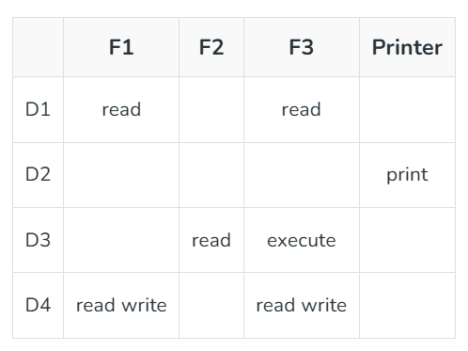
- There are four domains and four objects– three files(F1, F2, F3) and one printer.
- A process executing in D1 can read files F1 and F3.
- A process executing in domain D4 has same rights as D1 but it can also write on files.
- Printer can be accessed by only one process executing in domain D2.
- A process executing in domain D3 has the right to read file F2 and execute file F3.

Mechanism of Access Matrix
The mechanism of access matrix consists of many policies and semantic properties. Specifically, we must ensure that a process executing in domain Di can access only those objects that are specified in row i. Policies of access matrix concerning protection involve which rights should be included in the (i, j)th entry. We must also decide the domain in which each process executes. This policy is usually decided by the operating system. The users decide the contents of the access-matrix entries. Association between the domain and processes can be either static or dynamic. Access matrix provides a mechanism for defining the control for this association between domain and processes.

Switch operation: When we switch a process from one domain to another, we execute a switch operation on an object(the domain). We can control domain switching by including domains among the objects of the access matrix. Processes should be able to switch from one domain (Di) to another domain (Dj) if and only if a switch right is given to access(i, j)

